Language | Organisation | Pre-A1 | A1  ALTE Breakthrough | A2  ALTE Level 1 | B1  ALTE Level 2 | B2  ALTE Level 3 |  | C1  ALTE Level 4 | C2  ALTE Level 5
Basque  Euskara | Basque Government  Eusko Jaurlaritza |  |  |  |  |  |  | Euskararen Gaitasun Agiria (EGA)  - Audit valid until:  12 December 2021  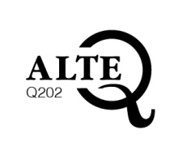
 | Government of Navarre  Gobierno de Navarra |  |  |  |  |  |  | Euskararen Gaitasun Agiria (EGA)  • Audit valid until :  17 October 2020  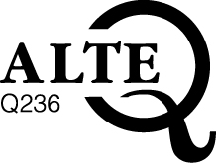
Bulgarian  Български език | Sofia University St. Kliment Ohridski – Department for Language Teaching -DLTIS  Софийски университет "Св. Климент Охридски" – Департамент за езиково обучение – ДЕО |  |  |  |  | Standardised Test in Bulgarian as a Foreign Language B2  - Audit valid until:  10 March 2020  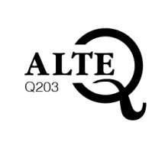
Catalan  Català | Generalitat of Catalonia  Generalitat de Catalunya |  |  |  |  |  |  |  | Nivell superior de català  - Audit pending
Czech  Čeština | Charles University in Prague, Institute for Language and Preparatory Studies (ILPS)  Univerzita Karlova v Praze, Ústav jazykové a odborné přípravy, (ÚJOP UK) |  | The Czech Language Certificate Exam (CCE) A1  - Audit valid until:  7 January 2021  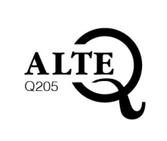 | The Czech Language Certificate Exam (CCE) A2  - Audit valid until:  7 January 2021 | The Czech Language Certificate Exam (CCE) B1  - Audit valid until:  7 January 2021 | The Czech Language Certificate Exam (CCE) B2  - Audit valid until:  7 January 2021 |  | The Czech Language Certificate Exam (CCE) C1  - Audit valid until:  7 January 2021
Danish  Dansk | The Ministry for Foreigners and Integration  (The Danish Teaching and Testing Unit) |  |  | Prøve i Dansk 1 (PD1)  - Audit valid until:  23 October 2022 | Prøve i Dansk 2 (PD2)  - Audit valid until:  23 October 2022 | Prøve i Dansk 3 (PD3)  - Audit valid until:  23 October 2022
Dutch  Nederlands | CNaVT  (Certificaat Nederlands als Vreemde Taal) |  |  |  |  | Educatief Startbekwaam (STRT) - B2  - Audit valid until:  24 April 2022  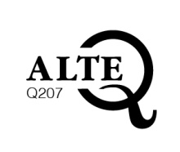
Dutch  Nederlands | The Interuniversity Testing Consortium (IUTC) |  |  |  |  | Interuniversitaire Taaltest Nederlands voor Anderstaligen – ITNA – B2  - Audit valid until:  15 June 2021  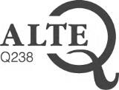 |  | Interuniversitaire Taaltest Nederlands voor Anderstaligen – ITNA – C1  - Audit valid until:  15 June 2021  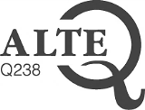
English  English | Cambridge Assessment  English |  |  | Cambridge English:  Key  - Audit valid until:  30 April 2023  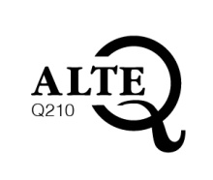 | Cambridge English: Preliminary  - Audit valid until:  30 April 2023 | Cambridge English:  First  - Audit valid until:  30 April 2023 |  | Cambridge English: Advanced  - Audit valid until:  30 April 2023 | Cambridge English: Proficiency  - Audit valid until:  30 April 2023
 |  |  |  | Cambridge English:  Key for Schools  - Audit valid until:  30 April 2023 | Cambridge English: Preliminary for Schools  - Audit valid until:  30 April 2023 | Cambridge English:  First for Schools  - Audit valid until:  30 April 2023
 |  | Cambridge English: Starters  - Audit valid until:  15 June 2020 | Cambridge English: Movers  - Audit valid until:  15 June 2020 | Cambridge English: Flyers  - Audit valid until:  15 June 2020 | Cambridge English:  Business Preliminary  - Audit valid until:  30 April 2023 | Cambridge English:  Business Vantage  - Audit valid until:  30 April 2023 |  | Cambridge English:  Business Higher  - Audit valid until:  30 April 2023
 | Trinity College  London  Trinity College  London | Graded Exams in Spoken English (GESE) Grade 1  - Audit valid until:  31 January 2024  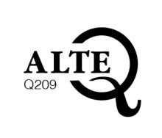 | Graded Exams in Spoken English (GESE) Grade 2  - Audit valid until:  31 January 2024 | Graded Exams in Spoken English (GESE) Grades 3 & 4  - Audit valid until:  31 January 2024 | Graded Exams in Spoken English (GESE) Grades 5 & 6  - Audit valid until:  31 January 2024 | Graded Exams in Spoken English (GESE) Grades 7, 8 & 9  - Audit valid until:  31 January 2024 |  | Graded Exams in Spoken English (GESE) Grades 10 & 11  - Audit valid until:  31 January 2024 | Graded Exams in Spoken English (GESE) Grade 12  - Audit valid until:  31 January 2024
 |  |  |  | Integrated Skills in English (ISE) Foundation  - Audit valid until:  31 January 2024 | Integrated Skills in English (ISE) 1  - Audit valid until:  31 January 2024 | Integrated Skills in English (ISE) 2  - Audit valid until:  31 January 2024 |  | Integrated Skills in English (ISE) 3  - Audit valid until:  31 January 2024 | Integrated Skills in English (ISE) 4  - Audit valid until:  29 November 2020
Estonian  Eesti keel | Foundation INNOVE |  |  | Eesti keele A2-taseme eksam  - Audit valid until:  24 April 2020  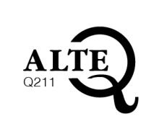 | Eesti keele B1-taseme eksam  - Audit valid until:  24 April 2020 | Eesti keele B2-taseme eksam  - Audit valid until:  24 April 2020 |  | Eesti keele C1-taseme eksam  - Audit valid until:  24 April 2020
Finnish  Suomi | University of Jyväskylä  Jyväskylän yliopisto |  |  |  | National Certificates of Language Proficiency (YKI): Finnish Intermediate Level  - Audit valid until:  15 June 2020  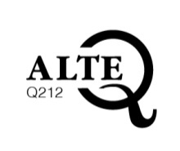 | National Certificates of Language Proficiency (YKI): Finnish Intermediate Level  - Audit valid until:  15 June 2020
French  Français  French  Français | CCIP |  | Test d’Evaluation de Français (TEF)  - e-tef  - TEFAQ  - e-tefaq  Audit valid until:  12 December 2021  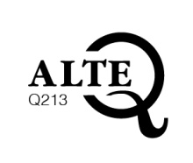
 | CCIP |  |  |  | Diplômes de Français Professionnel Affaires  - Audit valid until:  1 March 2024 | Diplômes de Français Professionnel Affaires  - Audit valid until:  1 March 2024 |  | Diplômes de Français Professionnel Affaires  - Audit valid until:  1 March 2024
 | CIEP  CIEP |  |  | DELF A2  - Audit valid until  3 May 2024  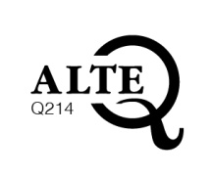 | DELF B1  - Audit valid until  3 May 2024 | DELF B2  - Audit valid until:  3 May 2024
Test de connaissance du français (TCF)
- TCF-TP
- TCF-DAP
- TCF-Québec
- TCF-ANF
- Audit valid until:
27 March 2020

Galician  Galego | Xunta de Galicia |  | CELGA (Certificación  en Lingua Galega) 1  - Audit in progress |  | CELGA (Certificación en Lingua Galega) 2  - Audit in progress
German  Deutsch  German  Deutsch  German  Deutsch  German  Deutsch | Goethe-Institut |  | Goethe Zertfikat A1 Start Deutsch 1  - Audit valid until:  3 May 2024  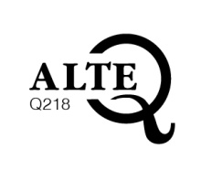 | Goethe Zertifikat A2 Start Deutsch 2  - Audit valid until:  3 May 2024 | Goethe Zertifikat B1  - Audit valid until:  3 May 2024 | Goethe-Zertifikat B2  - Audit valid until:  3 May 2024 |  | Goethe-Zertifikat C1  - Audit valid until:  3 May 2024 | Goethe-Zertifikat C2: Großes Deutsches Sprachdiplom  - Audit valid until:  3 May 2024
 | Goethe-Institut |  |  | Young Learners  Goethe Zertifikat A2 Fit in Deutsch  - Audit valid until:  3 May 2024 | Young Learners Goethe Zertifikat B1  - Audit valid until:  3 May 2024 | Young Learners  Goethe-Zertifikat B2  - Audit valid until:  3 May 2024
 | Telc gGmbH |  | Start Deutsch 1  telc Deutsch A1  - Audit valid until:  1 March 2024  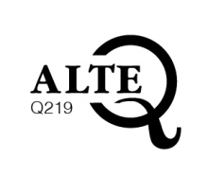 | Start Deutsch 2  telc Deutsch A2  - Audit valid until:  1 March 2024 | Zertifikat Deutsch B1  telc Deutsch B1  - Audit valid until:  1 March 2024 | telc Deutsch B2  - Audit valid until:  1 March 2024 |  | telc Deutsch C1 Hochschule  - Audit valid until:  10 January 2024
 | ÖSD |  | ÖSD Zertifikat A1 (ZA1)  - Audit valid until:  10 January 2024  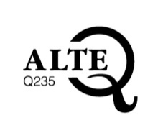 | ÖSD Zertifikat A2 (ZA2)  - Audit valid until:  10 January 2024 | ÖSD (Goethe) Zertifikat B1 (ZB1)  - Audit valid until:  17 December 2024
 | TestDaF-Institut |  |  |  |  | TestDaF  - Audit valid until:  27 February 2023  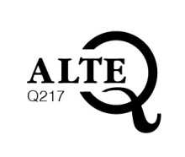
Hungarian  Magyar | ELTE Centre for Advanced Foreign Language Learning  ELTE Idegennyelvi Továbbképző Központ |  | ‘ORIGO’ Test of Hungarian as a Foreign Language (THFL) A1  - Audit in progress | ‘ORIGO’ Test of Hungarian as a Foreign Language (THFL) A2  - Audit in progress | ‘ORIGO’ Test of Hungarian as a Foreign Language (THFL) B1  - Audit in progress | ‘ORIGO’ Test of Hungarian as a Foreign Language (THFL) B2  - Audit in progress
Hungarian  Magyar | University of Pécs - Foreign Language Centre |  |  | ECL examination in Hungarian (A2)  - Audit valid until:  23 October 2022  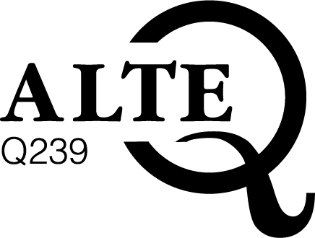 | ECL examination in Hungarian (B1)  - Audit valid until:  23 October 2022 | ECL examination in Hungarian (B2)  - Audit valid until:  23 October 2022 |  | ECL examination in Hungarian (C1)  - Audit valid until:  23 October 2022
Irish  Gaeilge | NUI Maynooth |  | TEG Bonnleibhéal 1 (A1)  - Audit valid until:  24 April 2020  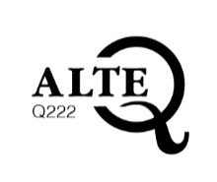 | TEG Bonnleibhéal 2 (A2)  - Audit valid until:  24 April 2020 | TEG Meánleibhéal 1 (B1)  - Audit valid until:  24 April 2020 | TEG Meánleibhéal 2 (B2)  - Audit valid until:  24 April 2020 |  | TEG Ardleibhéal 1  (C1)  - Audit valid until:  24 April 2020
Italian  Italiano | University for Foreigners Perugia  Università per Stranieri di Perugia |  |  | CELI 1  - Audit valid until:  30 April 2023  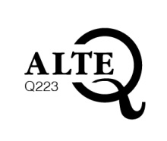 | CELI 2  - Audit valid until:  30 April 2023 | CELI 3  - Audit valid until:  30 April 2023 |  | CELI 4  - Audit valid until:  30 April 2023 | CELI 5  - Audit valid until:  30 April 2023
Luxembourgish  Lëtzebuergesch | Institut national des Langues |  |  | Sproochentest Lëtzebuergesch  - Audit in progress
Norwegian  Norsk | Skills Norway |  | Norskprøven for voksne innvandrere  - (A1-A2)  - (A2-B1)  - (B1-B2)  - Audit valid until:  - 30 April 2023  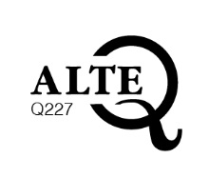
Polish  Polski | Jagiellonian University  Uniwersytet Jagielloński |  |  |  | Poziom podstawowy  - Audit in progress | Poziom średni ogólny  - Audit in progress |  |  | Poziom zaawansowany  - Audit in progress
Portuguese  Português | CAPLE (Centre for Assessment of Portugese as a Foreign Language)  CAPLE (Centro de Avaliação Português Língua Estrangeira) |  |  | Certificado Inicial de Português Língua Estrangeira (CIPLE )  - Audit in progress | Diploma Elementar de Português Língua Estrangeira (DEPLE)  - Audit in progress | Diploma Intermédio de Português Língua Estrangeira (DIPLE)  - Audit in progress |  | Diploma Avançado de Português Língua Estrangeira (DAPLE)  - Audit in progress | Diploma Universitário de Português Língua Estrangeira (DUPLE)  - Audit in progress
Romanian  Română | The Babeș-Bolyai University –Romanian Cultural Institute Consortium for Testing Romanian as a Foreign Language |  | Româna ca limbă străină (RLS), nivelul A1  - Audit valid until:  1 January 2021  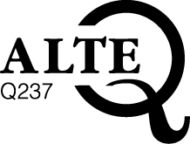 | Româna ca limbă străină (RLS), nivelul A2  - Audit valid until:  1 January 2021 | Româna ca limbă străină (RLS), nivelul B1  - Audit valid until:  1 January 2021 | Româna ca limbă străină (RLS), nivelul B2  - Audit valid until:  1 January 2021
Slovene  Slovenščina | Univerza v Ljubljani |  |  | Izpit iz znanja slovenščine na osnovni ravni  - Audit valid until:  23 October 2022 |  | Izpit iz znanja slovenščine na višji ravni  - Audit valid until:  23 October 2022 |  | Izpit iz znanja slovenščine na ravni odličnosti  - Audit valid until:  23 October 2022
Spanish  Español | Instituto Cervantes |  |  | DELE A2  - Audit in progress
Swedish  Svenska | Stockholm University |  |  |  |  |  |  | TISUS  - Audit valid until:  7 January 2021  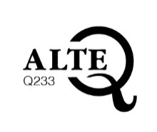
 | Stockholms universitet |  | National Test In Swedish for Immigrants  - Audit in progress | National Test In Swedish for Immigrants  - Audit in progress | National Test In Swedish for Immigrants  - Audit in progress
Welsh  Cymraeg | WJEC-CBAC |  | Defnyddio’r Gymraeg:  Mynediad  - Audit valid until:  1 March 2024  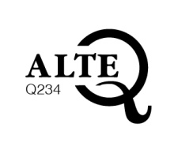 | Defnyddio’r Gymraeg: Sylfaen  - Audit valid until:  1 March 2024 | Defnyddio’r Gymraeg: Canolradd  - Audit valid until:  1 March 2024 | Defnyddio’r Gymraeg: Uwch  - Audit valid until:  1 March 2024

